Mac: Changing your Signature in Outlook
Select Outlook > Preferences. The Outlook Preferences window opens.
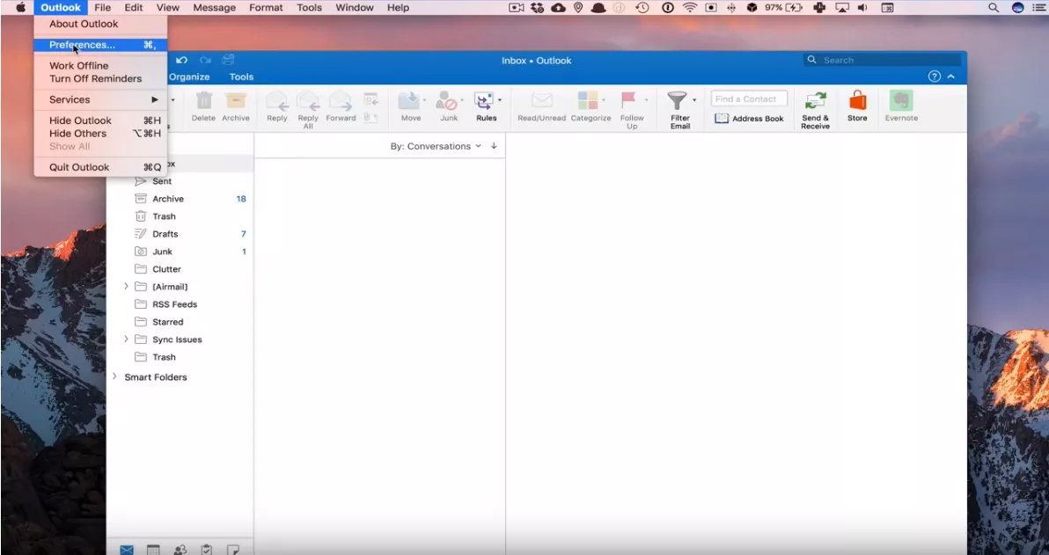
Select Signatures. The Signatures dialog box opens.
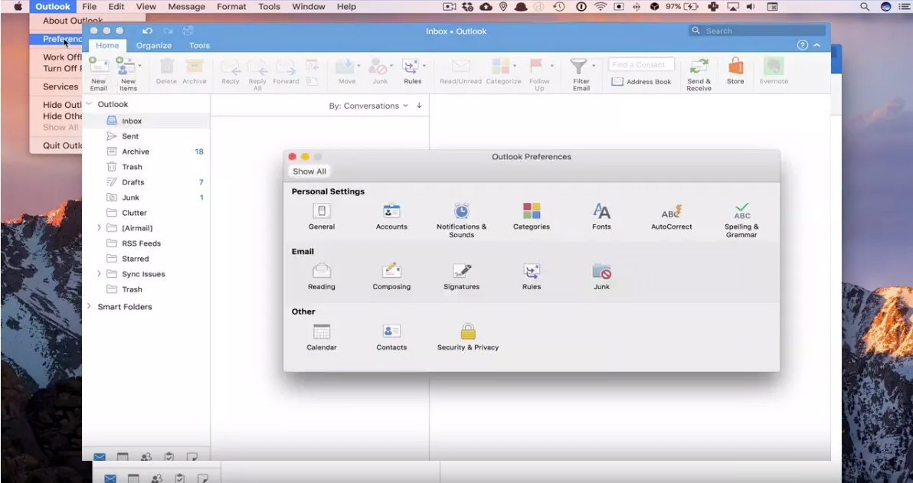

Select + beneath the list of signatures. A new signature line appears in the signature name list.

Input the following signature and modify with your information:
John Doe
Title
Oakland Schools
Department
O: 248.209.1234
M: 123.456.7890
2111 Pontiac Lake Rd.
Waterford, MI 48328

Choose this signature for New Messages.
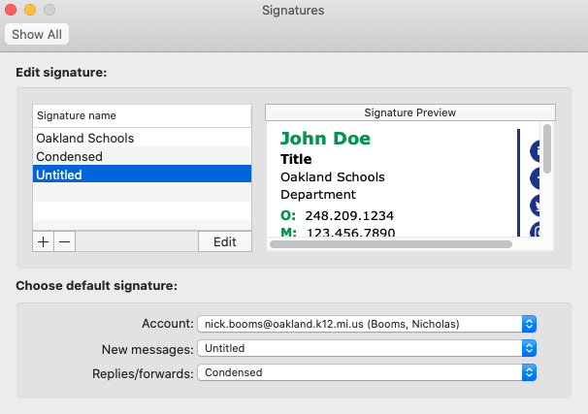
Save and Select OK.
You can repeat the same instructions and set the following format as your signature for replies/forwards to reduce length of emails.
-John Doe

